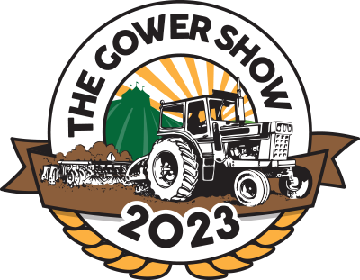

GOWER AGRICULTURAL SHOW
VINTAGE VEHICLES
Sunday 6th August 2023 at
Penrice Castle Park Penrice Estate,
Gower SA3 1LA
Over the last few years exhibits in the mobile vintage section has grown and due to revised Health and Safety regulations for exhibitors and the show visitors,
all exhibitors in this section need to apply prior to the show for exhibitor passes. No exhibitor pass – no entry. Tickets will need to be purchased for any passengers.

All vehicles to be on the show ground by 8.30am. A small description of the vehicle to be on display. An owner is requested to remain with their vehicle other than for meals or comfort stops.
No vehicle is to be removed before 5pm.
Please indicate if you wish to join the parade in the main ring.
All entries to be returned no later than Sunday 30th July 2023 to-
Mrs Margaret Davies, Mobile Vintage Secretary, 20 Llan yr Newydd, Penclawdd, SA4 3JL Tel: 07495288207
email: margaret.davies2008@live.co.uk

ENTRY FORM
EXHIBITORS NAME | ADDRESS | CONTACT DETAILS | DESCRIPTION OF VEHICLE

VINGAGE VEHICLES INFORMATION SHEET

Make ........................................................

Model .........................................................

Date .................Horse Power ....................

History ............................................................
....................................................................................................................................................................................................................................................................................

Owner.........................................................

Notes ...............................................................................................................................................................................................................

